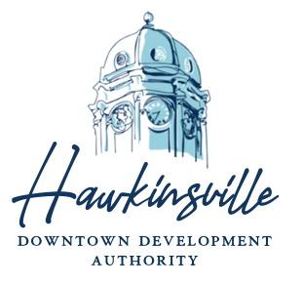
TUESDAY, NOVEMBER 18, 2025
10:00 A.M. CITY HALL COMMISSIONER BOARD ROOM
56 BROAD STREET, HAWKINSVILLE, GA 31036

AGENDA
ROLL CALL:
CALL TO ORDER:

REVIEW/APPROVE: Tuesday, November 18, 2025, Agenda

REVIEW/APPROVE: Tuesday, October 14, 2025, HDDA Regular Meeting Minutes,
with changes, if any

REVIEW/APPROVE: Tuesday, October 14, 2025, HDDA Retreat Meeting Minutes,
with changes, if any

REVIEW/APPROVE: HDDA Financials and Bank Statements for October 2025

REVIEW/APPROVE: Façade Grant for 72 Houston Street- Genuine Gents

REVIEW/APPROVE: 2026 Work Plan Goals

REVIEW/APPROVE: 2026 Downtown Hawkinsville Match Grant

REVIEW/APPROVE: Discontinuing the Façade Loan Program for 2026

REVIEW/APPROVE: Payment to Johnson Electric for Work on Digital Sign
REVIEW/APPROVE: Updated Assistant’s Computer Budget
DISCUSSION: Training Hours
INFORMATION: Upcoming Events, Meetings and Trainings:
      - Training- Coffee and Conversations- November 20, 2025, at 10 AM
      - Holiday Decoration Contest Sign Up Deadline- November 19, 2025
      - Holiday Open House Sign Up Deadline- November 21, 2025
      - Holiday Open House & Decoration Announcement- November 29, 2025
      - Training- Coffee and Conversations- December 18, 2025, at 10 AM
      - Main Street and Downtown Development Meeting- February 10, 2026

REVIEW/ APPROVE: River Market Selling Price and Terms

REVIEW/APPROVE: Employment Offer to Selected Applicant
ECONOMIC
DEVELOPMENT
/MAINSTREET
DIRECTOR REPORT:

MAIN STREET
COMMITTEE
COMMENTS:

EXECUTIVE
SESSION
(If needed):

ADJOURN:

